AquaPulse - Birthday Party Catering Menu
This form must be submitted a minimum of 2-weeks prior to the confirmed booking date.

BOOKING NAME
BOOKING TIME
REQUESTED FOOD DELIVERY TIME

 | Serves | Price | Qty | Total
HOT FOOD
PARTY PIES (24 pcs) | 6–8 ppl | $28.00
PARTY SAUSAGE ROLLS (24 pcs) | 6–8 ppl | $28.00
HOT CHIPS Veg, Vegan | 4–6 ppl | $22.00
CHICKEN NUGGETS (24 pcs) | 4–6 ppl | $22.00
COLD FOOD
¼ GOURMET SANDWICHES (assorted) | 10-12 ppl | $80.00
DIETARY REQUIREMENTS
PARTY VEGE PASTIE (6 pcs) Veg | 1–2 ppl | $16.00
PARTY SPINACH & RICOTTA ROLL (6 pcs) Veg | 1–2 ppl | $16.00
GLUTEN FREE CHICKEN NUGGETS (6 pcs) GF | 1–2 ppl | $10.00
DRINKS
Pop Top Juice 250ml |  | $2.70
Cool Ridge Water 600ml |  | $3.50
EXTRAS
Plates/Napkins required? |  | $2.00
Tomato Sauce Sachets |  | .30c
TOTAL

- BYO Birthday Cakes. Fridge space is limited - Space permitting, we may be able to store your cake. Ice Cream cakes cannot be stored.
- You may purchase additional Café items on the day at regular retail price (if available).

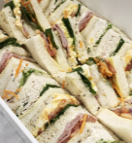 ¼ GOURMET SANDWICHES (assorted) - $80.00 - Serves 10-12
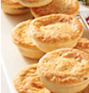 PARTY PIES (24 pieces) - $28.00 - Serves 6-8
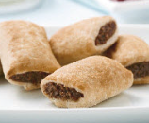 PARTY SAUSAGE ROLLS (24 pieces) - $28.00 - Serves 6-8

 HOT CHIPS - $22.00 - Serves 4-6 (Veg, Vegan)
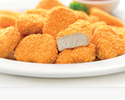 CHICKEN NUGGETS (24 pieces) - $22.00 - Serves 4-6

